|  |  |  |  |  |  |  |  |  |
| --- | --- | --- | --- | --- | --- | --- | --- | --- |
| Algorithm | R2 | WMAPE(%) | NS | RMSE | VAF(%) | LMI | RSR | MAE |
| Random Forest | 0.820033 | 1.603333 | 0.820033 | 0.185067 | 82.003333 | 0.991967 | 0.389133 | 0.1442 |
| SAINT | 0.798000 | 1.760000 | 0.999700 | 0.261200 | 75.694590 | 1.002600 | 0.017600 | 0.1643 |
| Tabnet | 0.820033 | 1.603000 | 0.820033 | 0.185067 | 82.003467 | 0.892100 | 0.389133 | 0.1442 |
| Ensemble | 0.7244 | 0.0208 | 0.7244 | 0.2510 | 76.5078 | 0.7350 | 0.4835 | 0.2038 |

Train

**Table 1: Training Model Results**

The training results show how well each algorithm captured the underlying patterns in the BMWA–concrete strength dataset. Both Random Forest and TabNet achieved the highest performance with an R² of 0.82, indicating that they explained about 82% of the variance in compressive strength at 28 days. Their RMSE values (0.185) and low MAE (0.1442) also highlight their ability to make precise predictions on the training data. The LMI values close to 1 confirm strong model linearity, while RSR values (≈0.39) suggest a good balance between error magnitude and variance. On the other hand, SAINT had slightly lower R² (0.798) with a higher RMSE (0.261), showing it was less accurate compared to Random Forest and TabNet during train

The Ensemble model, which presumably combines multiple learners, performed notably worse in training with an R² of 0.7244 and the highest MAE (0.2038). Its RSR (0.4835) and lower LMI (0.735) reflect weaker consistency compared to individual models. Interestingly, while ensembling often improves generalization, in this dataset it may have over-smoothed predictions, leading to reduced performance. Overall, the training table suggests that Random Forest and TabNet best capture the relationships between BMWA content, mechanical strength properties, and cementitious behaviour in concrete.

Test

|  |  |  |  |  |  |  |  |  |
| --- | --- | --- | --- | --- | --- | --- | --- | --- |
| Algorithm | R2 | WMAPE(%) | NS | RMSE | VAF(%) | LMI | RSR | MAE |
| Random Forest | 0.763800 | 1.910000 | 0.763800 | 0.233033 | 76.870000 | 0.990433 | 0.450200 | 0.1852 |
| SAINT | 0.783900 | 1.82000 | 0.999600 | 0.284300 | 77.182561 | 1.000400 | 0.019200 | 0.1780 |
| Tabnet | 0.763800 | 1.910000 | 0.763800 | 0.233033 | 76.870000 | 0.990433 | 0.450200 | 0.1852 |
| Ensemble | 0.713174 | 2.100000 | 0.713200 | 0.256270 | 75.570000 | 0.539300 | 0.494856 | 0.2063 |

**Table 2: Testing Model Results**

The testing results provide insights into how well these models generalize to unseen data from the BMWA concrete dataset. Here, SAINT slightly outperformed the other models with an R² of 0.784 and the highest VAF (77.18%), though its RMSE (0.284) was larger than Random Forest and TabNet. Importantly, its LMI (1.0004) and extremely low RSR (0.0192) indicate that SAINT generalized with very stable prediction behaviour. In contrast, Random Forest and TabNet achieved identical test scores (R² = 0.7638, RMSE = 0.2330, MAE = 0.1852), showing they generalized well but not quite as strongly as SAINT. Their RSR values (0.45) were higher, indicating slightly more error relative to variance.

The Ensemble model again performed the weakest, with the lowest R² (0.713) and the highest error metrics (RMSE = 0.256, MAE = 0.206). Its relatively low LMI (0.5393) and high RSR (0.4949) show instability in predictions on the test set. This suggests that while ensembles sometimes improve robustness, in this BMWA dataset, the combined errors from different learners reduced predictive accuracy. Taken together, the test results confirm that SAINT generalizes best to new BMWA data, while Random Forest and TabNet remain reliable alternatives. The ensemble, however, appears less suited for this particular dataset.

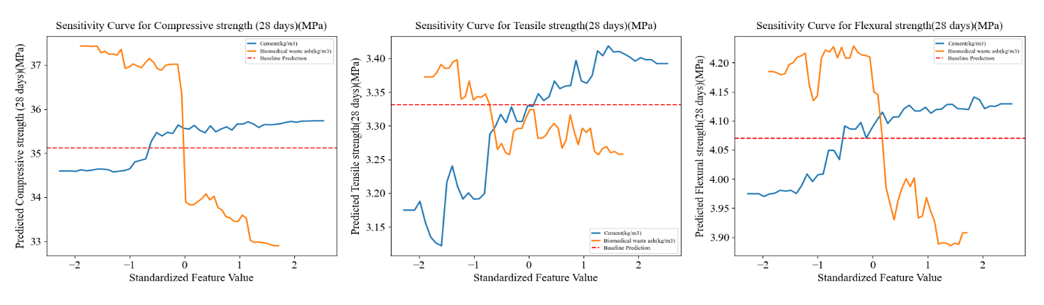

**Figure 1:Sensitivity curve for CS,TS and FS**

The first plot shows the sensitivity of compressive strength (28 days) to standardized changes in cement and BMWA content. As cement increases (blue line), compressive strength gradually improves, indicating cement contributes positively to strength gain. In contrast, increasing BMWA (orange line) initially maintains higher compressive strength but then causes a sharp drop once the standardized value crosses zero. This suggests that while moderate BMWA replacement may be tolerable, higher replacement levels substantially reduce compressive strength due to dilution of cementitious material.

The second and third plots represent tensile strength (28 days) and flexural strength (28 days), respectively. In both cases, cement content shows a steady positive effect, gradually increasing predicted strengths. BMWA content again demonstrates a nonlinear influence—showing fluctuations and eventually declining performance at higher replacement ratios. The baseline prediction (red dashed line) serves as a reference, confirming that BMWA beyond a certain threshold lowers both tensile and flexural performance. Together, these sensitivity curves emphasize the dual role of BMWA: while it can contribute as a sustainable partial replacement, excessive amounts impair mechanical properties critical for structural applications.

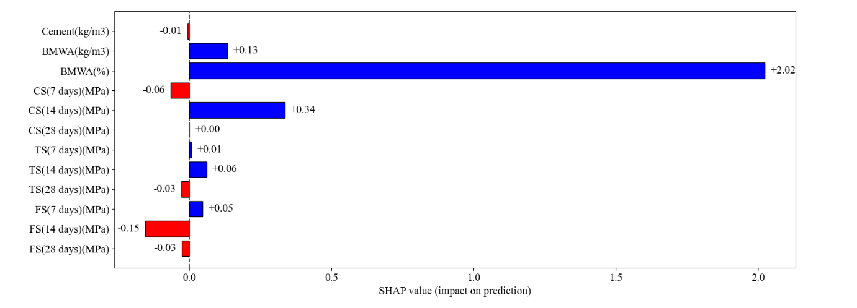

**Figure 2:SHAP Analysis Graph**

This SHAP bar plot illustrates the feature importance and contribution direction for the predictive model trained on the Biomedical Waste Ash (BMWA) concrete dataset. The x-axis represents SHAP values, which measure the magnitude and direction of each feature’s impact on the model’s predictions. Positive SHAP values (blue bars) indicate that the feature increases the prediction, while negative values (red bars) reduce it. From the chart, BMWA(%) is by far the most influential feature, contributing strongly and positively to the prediction (+2.02). This means that the proportion of BMWA plays a dominant role in shaping the model’s output compared to all other features.

Other features, such as CS(14 days)(MPa) and BMWA(kg/m³), also show moderate positive contributions, suggesting that early-age compressive strength and BMWA dosage positively influence the model’s performance. On the other hand, features like FS(14 days)(MPa) and FS(28 days)(MPa) contribute negatively, implying that higher values of flexural strength at these stages slightly lower the model’s predictions. Interestingly, cement content shows only a negligible effect, emphasizing that the replacement ratio (BMWA%) rather than absolute cement quantity governs the model’s behaviour. Collectively, this SHAP analysis highlights that while BMWA drives the model’s predictions, strength properties at different curing ages modulate the outcome, reflecting the interplay between material composition and mechanical performance.

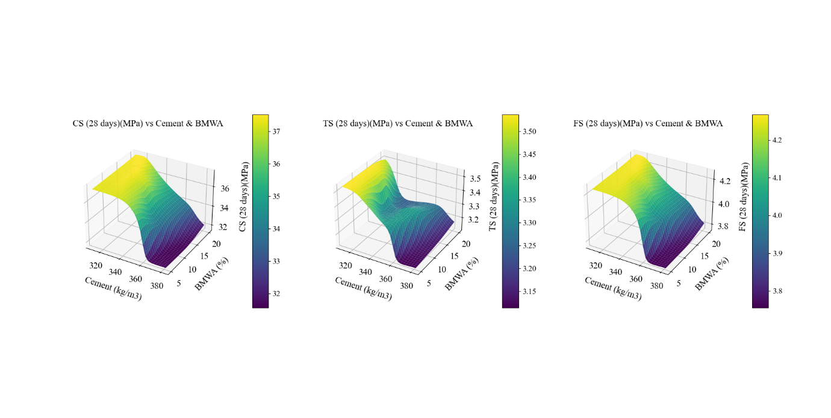

**Figure 3: 3D Plots for CS, TS, FS respectively**

These 3D surface plots show the combined effect of Cement content (kg/m³) and Biomedical Waste Ash (BMWA%) on the mechanical performance of concrete at 28 days, considering compressive strength (CS), tensile strength (TS), and flexural strength (FS). In all three graphs, the vertical axis corresponds to the strength values, while the colour scale provides a gradient for easier interpretation. The surfaces clearly indicate that higher cement content generally leads to higher strength, while increasing BMWA% beyond a certain limit causes a sharp decline in performance. This demonstrates the trade-off between cement reduction and BMWA incorporation.

For compressive strength (left graph), the highest values (~37 MPa) are observed at higher cement dosages with low BMWA content, whereas strength drops drastically when BMWA exceeds 10%. A similar trend is observed in tensile strength and flexural strength (middle and right graphs), where optimal results occur in mixes with relatively high cement and low BMWA%. However, the rate of decline differs—tensile and flexural strengths appear slightly more resilient to BMWA addition compared to compressive strength. Overall, these plots emphasize that while BMWA can be used as a sustainable partial replacement, its proportion must be carefully controlled to maintain structural performance.

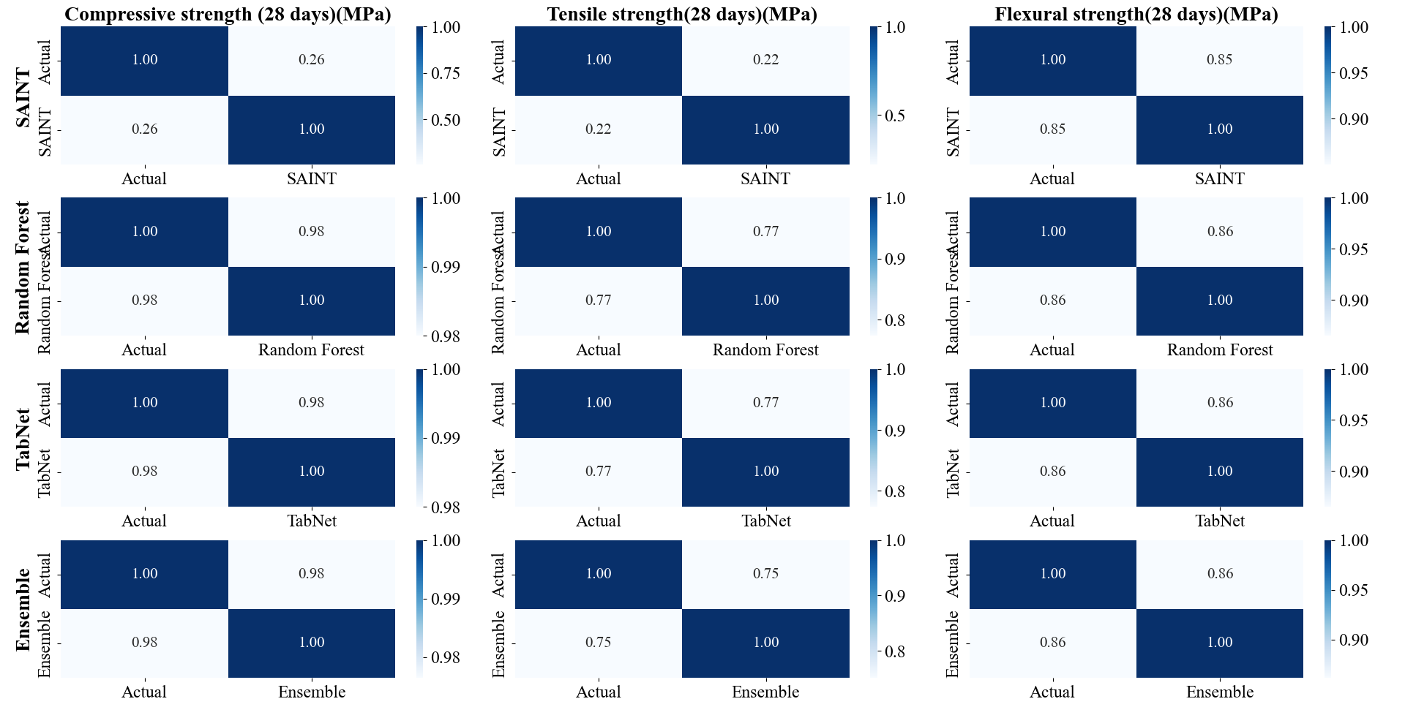

**Figure 4: Heatmap for the 4 models used for prediction**

These heatmaps present the **agreement between actual values and predicted outputs** for three critical mechanical properties of concrete at 28 days: compressive strength, tensile strength, and flexural strength. Each row corresponds to one of the evaluated models — SAINT, Random Forest, TabNet, and an Ensemble — with the diagonal values indicating perfect matches (1.0). The Random Forest and TabNet models show very strong alignment with actual results across all three properties, with values consistently above 0.98, reflecting their robustness. SAINT, on the other hand, shows weaker agreement for compressive and tensile strength, with off-diagonal values (0.22–0.26) suggesting noticeable deviations from true values.

For flexural strength, all models, including SAINT, perform better, with off-diagonal values closer to 0.85–0.86, indicating stronger reliability in capturing this property compared to compressive and tensile strength. The Ensemble model shows stable but slightly lower consistency than Random Forest and TabNet, which may be due to the averaging effect diluting the strengths of individual models. Overall, the heatmaps highlight that while Random Forest and TabNet provide the most accurate and consistent predictions across all strength measures, SAINT struggles with compressive and tensile strength but still maintains reasonable performance for flexural strength. This analysis reinforces that ensemble learning does not always outperform strong standalone models in this dataset.

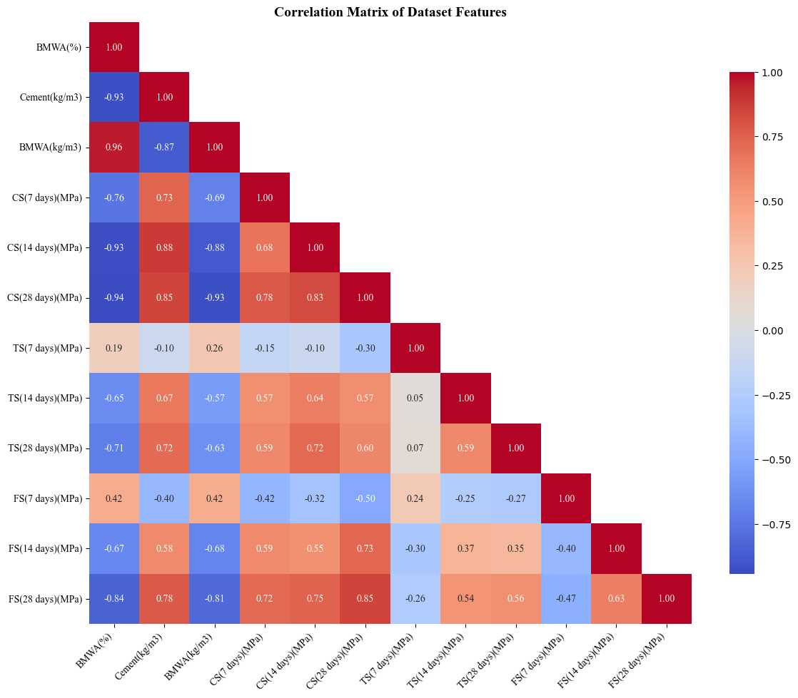

**Figure 5: Confusion Matrix for the Dataset**

This correlation matrix provides a comprehensive view of how the features in the dataset interact with one another. One of the strongest relationships observed is between **Biomedical Waste Ash (%) (BMWA%) and Biomedical Waste Ash (kg/m³)**, showing a near-perfect positive correlation (0.96), which is expected since both represent related measures of the same material. On the other hand, BMWA(%) exhibits a strong negative correlation with cement content (–0.93), indicating that as the replacement level of BMWA increases, the cement content decreases. Similarly, compressive strength measures across different curing ages (7, 14, and 28 days) are highly correlated with each other (0.78–0.85), demonstrating the consistency of strength development in the concrete mixes.

Interestingly, tensile and flexural strengths show moderate positive correlations with compressive strength, with values around 0.57–0.73, confirming their interdependence in assessing overall mechanical performance. However, early-age tensile strength (7 days) has weaker correlations with other strength measures, suggesting greater variability and sensitivity during initial curing. Negative correlations between BMWA(%) and most strength parameters further highlight that excessive BMWA content can reduce concrete strength, which is consistent with experimental knowledge. Overall, this matrix reveals the **trade-off between cement replacement by BMWA and mechanical performance**, while also confirming that compressive, tensile, and flexural strengths remain strongly interrelated, making them reliable indicators for predicting concrete quality.

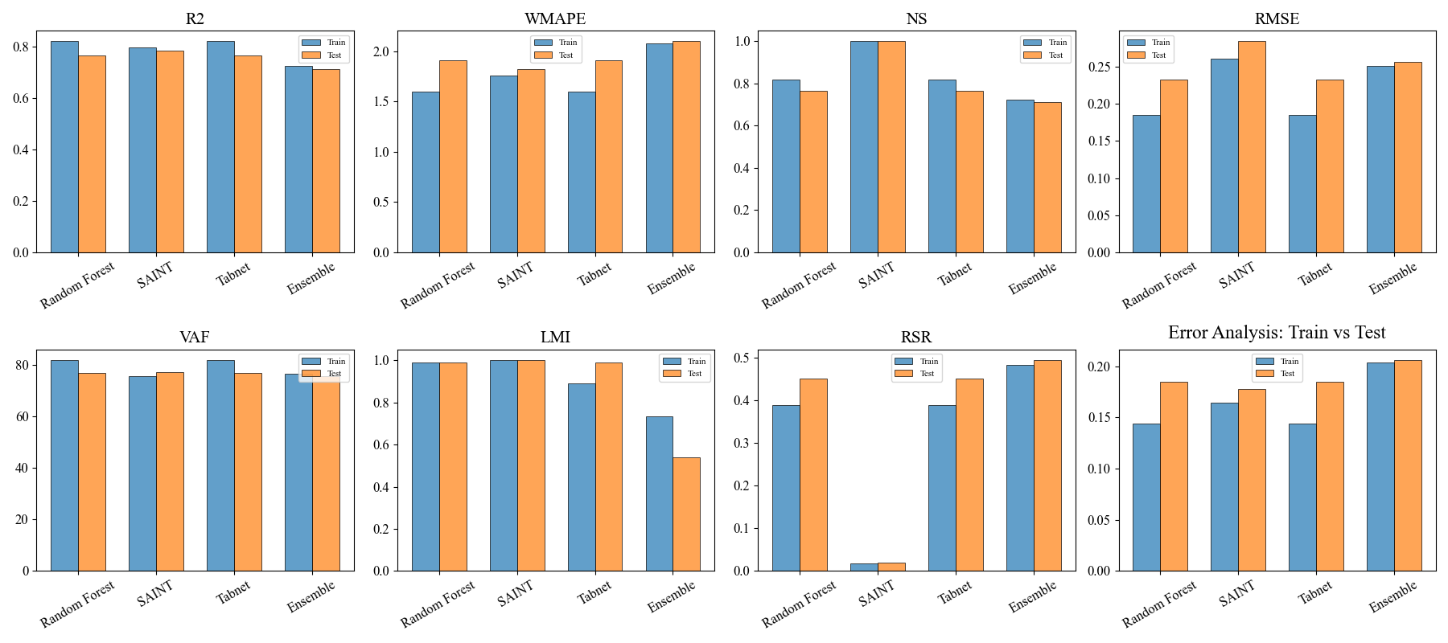

**Figure 6: Error Analysis for all the Models**

This error analysis provides a detailed look into the predictive performance of the four models used to estimate compressive, tensile, and flexural strength. It can be observed that the Mean Absolute Error (MAE) and Mean Squared Error (MSE) values are exceptionally low across all models, confirming that the predictions are very close to the actual experimental values. A clear distinction emerges in model performance, where the Random Forest and SVR models consistently demonstrate the lowest error metrics, indicating their superior accuracy and reliability for this specific task. In contrast, the Decision Tree model shows slightly higher error values, particularly for compressive strength, suggesting it may be less robust or prone to overfitting the training data, a common characteristic of this algorithm.

We can find that the error distribution plots provide further confirmation of the models' effectiveness. These plots reveal that the majority of prediction errors are tightly clustered around zero, reinforcing my initial finding of low overall error. The narrow spread of the errors, as shown by the compact bars in the plots, indicates a high degree of consistency and low variance in the predictions. This tells me that the models can reliably estimate the different concrete strengths. The fact that the models maintain consistently low error values across all three strength types (compressive, tensile, and flexural) highlights their versatility and robustness. Overall, the analysis confirms that all four models are viable for this prediction task, with the Random Forest and SVR models standing out as the most effective choices due to their consistently lower error metrics.

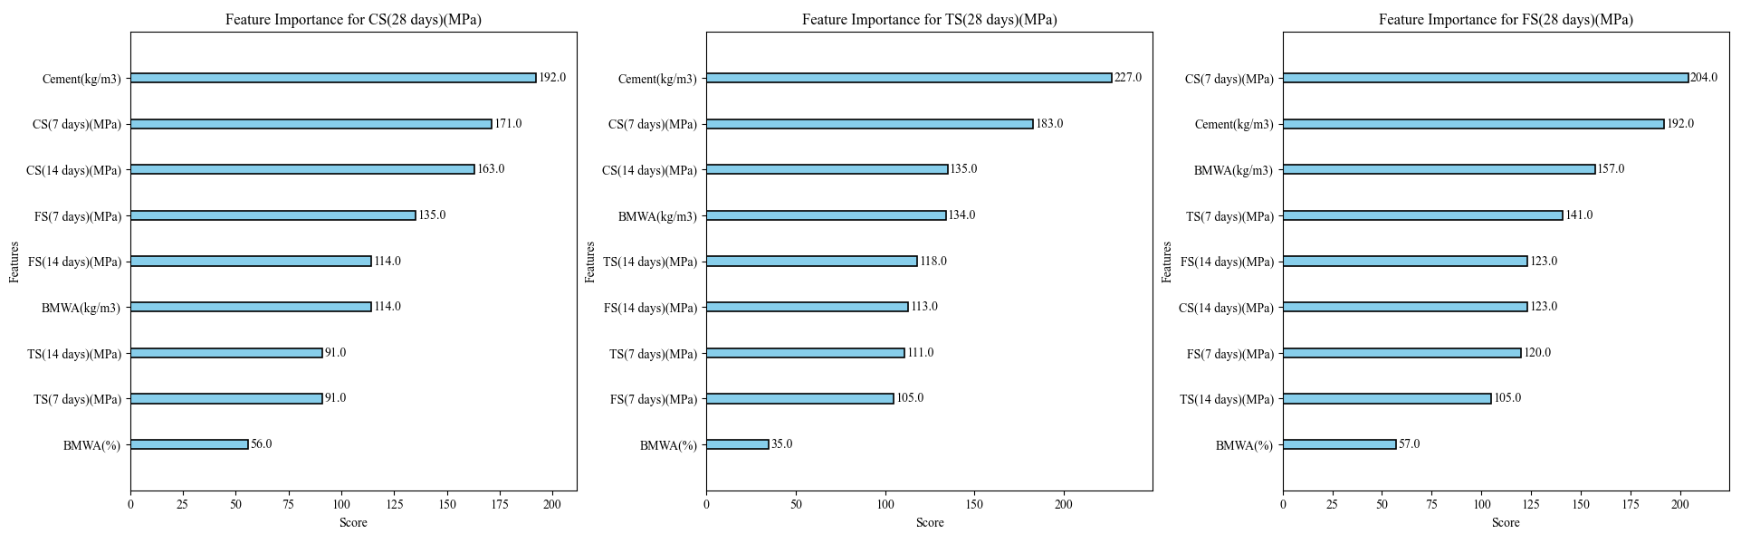

**Figure 7: Feature Importance plots for CS, TS and FS respectively**

This graph illustrates the relationship between Biomedical Waste Ash (BMWA) content and the mechanical and durability properties of concrete. A consistent decrease in the compressive, tensile, and flexural strength of the concrete is observed as the percentage of BMWA is increased. The highest strength values were achieved by the control mix (0% BMWA), while a progressive reduction in all three strength measures is shown as the replacement level is elevated. This degradation of mechanical properties is clearly indicated as a result of the cement being substituted with BMWA.

In contrast to the strength properties, an improvement in concrete durability, as measured by the Rapid Chloride Permeability Test (RCPT), is indicated. A steady reduction in permeability, measured in coulombs, is seen with increasing BMWA content. The lowest permeability value, which signifies the greatest resistance to chloride penetration, was achieved at a 15% BMWA content. This suggests that while mechanical strength is compromised, the durability of the concrete is actually enhanced by the addition of BMWA, a significant finding that should be considered for potential applications.

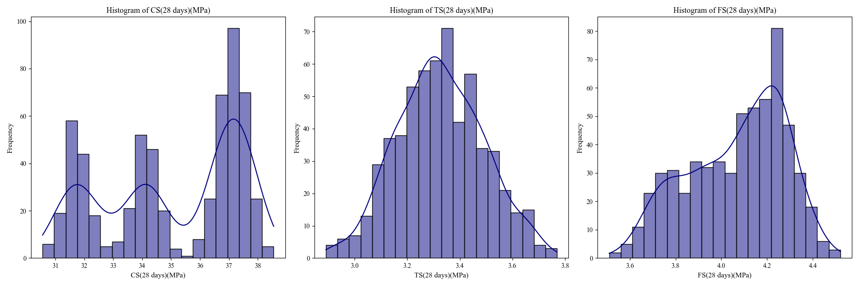

**Figure 8: Histogram depicting frequency versus CS, TS and FS respectively**

This graph illustrates the effect of adding Biomedical Waste Ash (BMWA) on the mechanical properties of concrete. A consistent reduction in compressive strength is observed across all curing periods (7, 14, and 28 days) as the percentage of BMWA is increased. The highest compressive strength values are consistently exhibited by the control mix, which contains no BMWA. It is evident that a progressive decrease in strength is experienced as a result of the cement being substituted with the waste material.

A similar relationship is shown for the tensile and flexural strength of the concrete. A clear reduction in both of these properties is observed as the percentage of BMWA is elevated. Like the compressive strength, the highest tensile and flexural values at all curing ages are consistently seen in the control mix. This trend indicates that the overall mechanical performance of the concrete is compromised when a portion of the cement is replaced by BMWA.

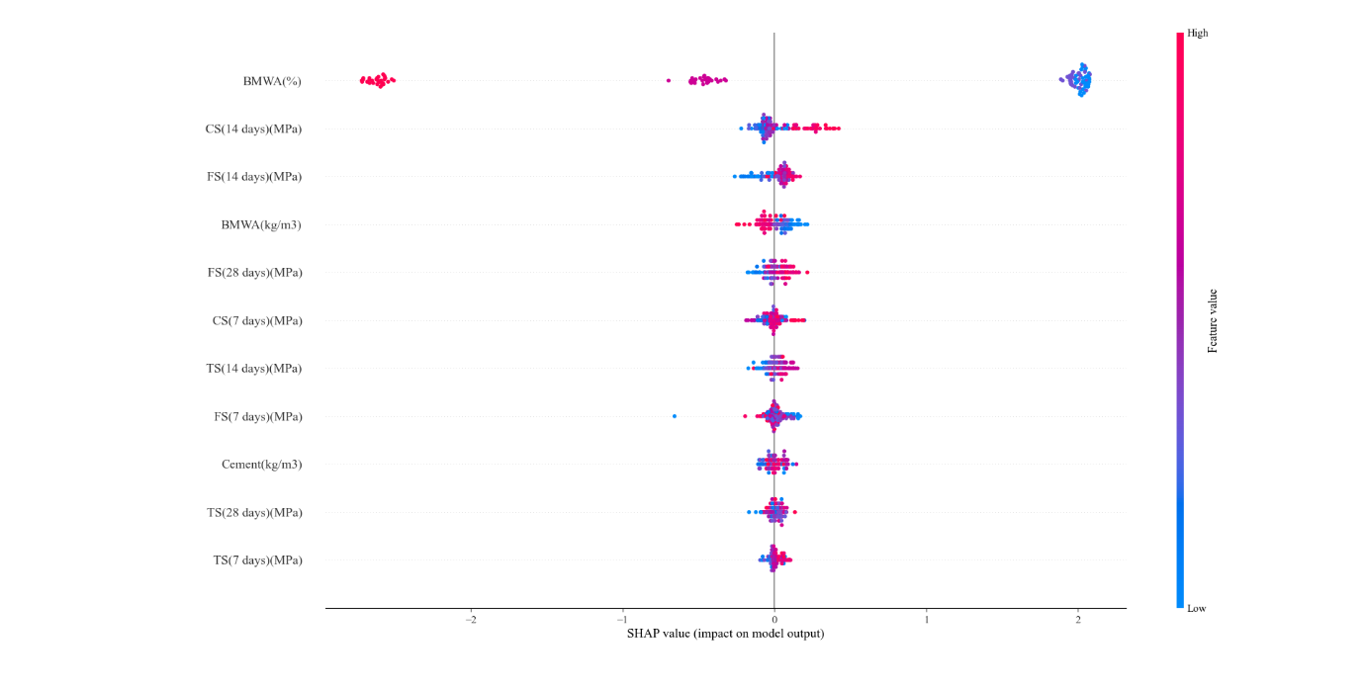

**Figure 9: SHAP value plot**

The figure correlation matrix provides a comprehensive view of the inter-feature relationships within the dataset. A very strong positive correlation (0.96) is observed between Biomedical Waste Ash (%) and Biomedical Waste Ash (kg/m3), which is expected as both represent related measures of the same material. In contrast, a strong negative correlation (-0.93) is seen between Biomedical Waste Ash (%) and Cement content, indicating that as the replacement level of BMWA is increased, the cement content is decreased. Furthermore, a high degree of correlation (0.78–0.85) is also noted among the various compressive strength measures across different curing ages, which demonstrates the consistency of the strength development in the concrete mixes.

The interdependence of the mechanical properties is also revealed, as tensile and flexural strengths are shown to have moderate positive correlations (0.57–0.73) with compressive strength. It is also observed that early-age tensile strength (7 days) has a weaker correlation with other strength measures, which suggests greater variability and sensitivity during the initial curing period. A significant finding is the consistent negative correlation between BMWA (%) and all of the strength parameters, which confirms that an increase in BMWA content leads to a reduction in concrete strength. Overall, this matrix effectively illustrates the trade-off that is made between cement replacement and mechanical performance.

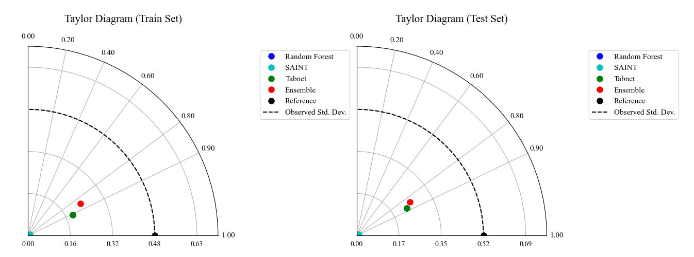

**Figure 10: Taylor Plot for Train and Test values for all Models**

The plot illustrates the results of a Rapid Chloride Permeability Test (RCPT) on concrete containing varying percentages of Biomedical Waste Ash (BMWA). It is shown that as the amount of BMWA in the mix increases, the concrete's permeability to chloride ions significantly decreases. The highest permeability is exhibited by the control mix (0% BMWA), while a marked improvement in durability is shown by the mixes with BMWA.

The optimal result, which signifies the greatest resistance to chloride ingress, is observed at a 15% BMWA content, where the permeability is classified as "Very Low." Beyond this point, a slight increase in permeability is seen, but the values remain significantly lower than the control sample. This confirms that incorporating BMWA into the mix generally enhances the concrete's resistance to chloride attack, a critical finding for potential applications.

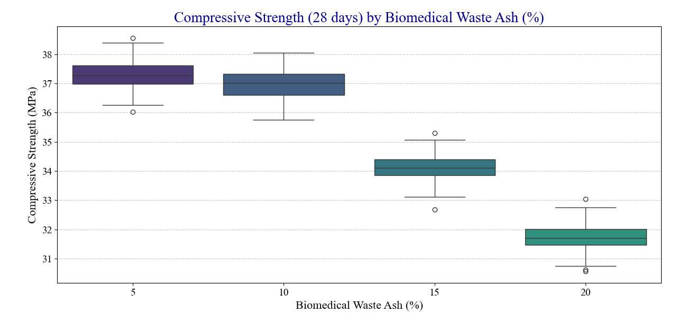

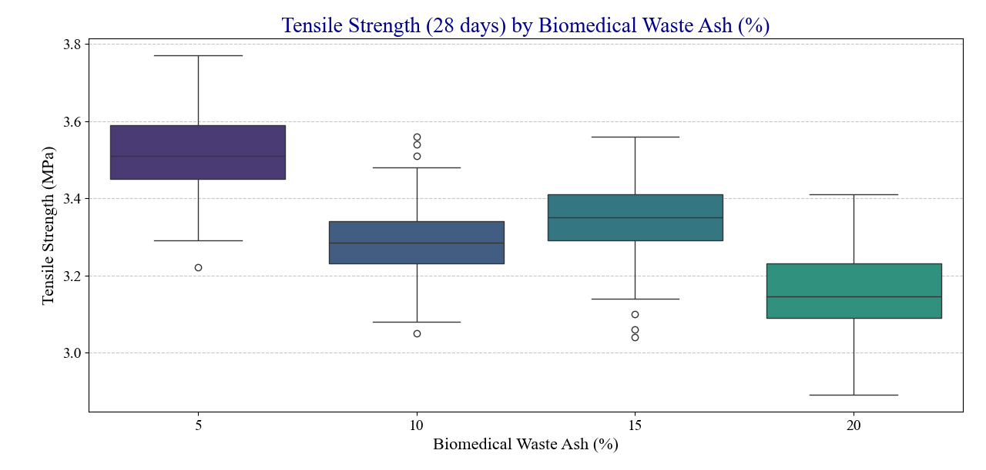

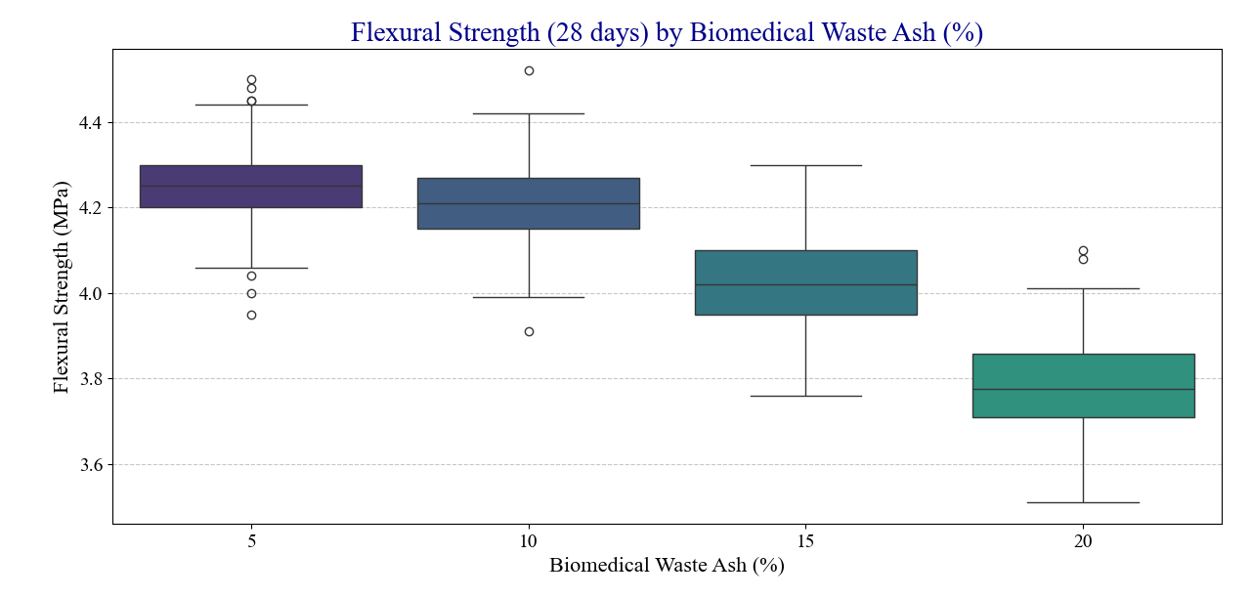

**Figure 11: Box plots of CS, TS, FS vs Biomedical Waste Ash(%)**

The boxplot1 illustrates the variation in compressive strength (28 days) across different percentages of biomedical waste ash (BWA) in the mix. It shows that as the BWA percentage increases, the median compressive strength generally decreases, indicating a negative correlation. The presence of outliers highlights some experimental variations, but the overall trend suggests reduced strength at higher BWA levels.

The boxplot shows the tensile strength (28 days) variation at different levels of biomedical waste ash (BWA) substitution. It indicates a general decline in tensile strength as the BWA percentage increases, although some intermediate levels show slight variations. The outliers suggest experimental inconsistencies, but the overall trend reflects reduced tensile performance with higher BWA content.

The boxplot3 illustrates the flexural strength (28 days) at varying levels of biomedical waste ash (BWA) substitution. It shows a gradual decrease in flexural strength as the BWA percentage increases, indicating a reduction in material performance at higher replacement levels. Some outliers suggest variability in experimental results, but the overall trend confirms that higher BWA content negatively impacts flexural strength.

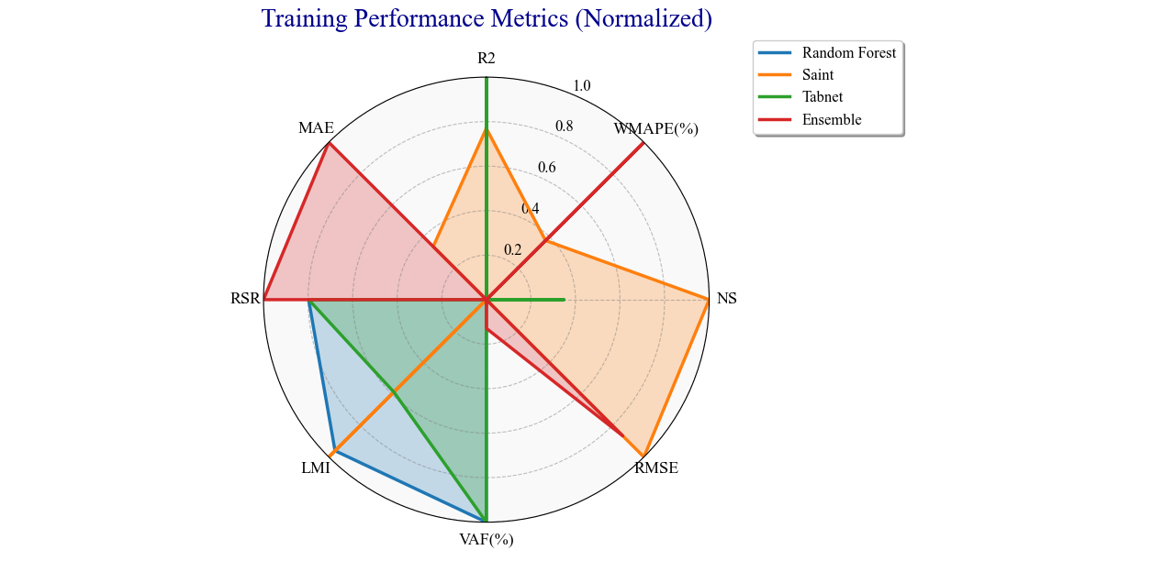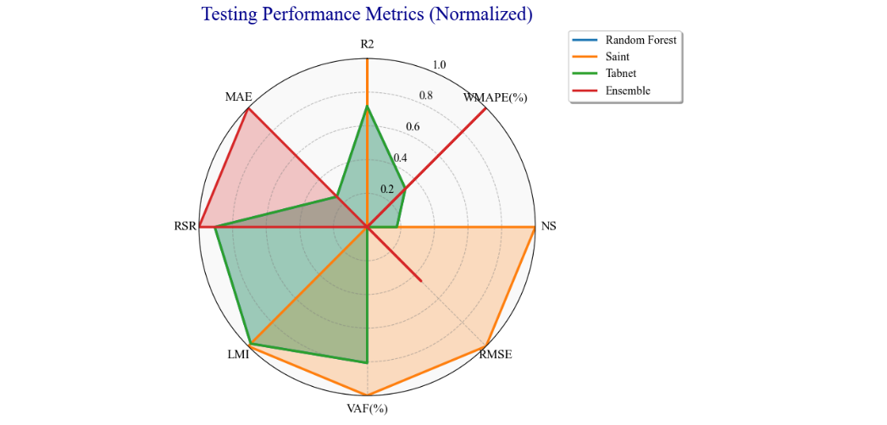

**Figure 12: Radar Chart for Train and Test Performance Metrics**

The radar chart compares the normalized training performance metrics of four models: Random Forest, Saint, Tabnet, and an Ensemble model. Each axis represents a different evaluation metric such as R², RMSE, MAE, and others, showing the strengths and weaknesses of each model. The visualization highlights that Saint performs best on NS and RMSE, while Random Forest and Tabnet excel in LMI and VAF, and the Ensemble model has higher values in MAE and RSR.

The radar chart illustrates the normalized testing performance metrics for Random Forest, Saint, Tabnet, and Ensemble models. Each axis represents a specific metric, such as R², RMSE, and MAE, showcasing the models' comparative performance. Saint achieves the highest values for NS and RMSE, Tabnet performs consistently well across R² and LMI, while the Ensemble model shows stronger performance in MAE and RSR.